H-CDL tools to develop URS

CTRL Designer LLC

2024.10.10

Table of contents

# 1. Introduction

CTRL Designer LLC (**CDL**) is a leading provider of **SBC** state-based control (procedural control) based on ISA106 solutions to the process industries.

Its software portfolio and work processes help process control engineers develop an overall process control design and convert it automatically to the selected control system code. These solutions allow users to make smarter decisions to improve safety, reliability, efficiency, and sustainability.

The following are discussed as an introduction to CDL interpretation of ISA106.

| Chapter | description |
| --- | --- |
| A | ISA106 Overview |
| B | ISA106 Models |
| C | ISA106 Automation Styles |
| D | ISA106 State-Based Control (SBC) |
| E | ISA106 Sequenced-Based Control (SqBC) |
| F | ISA106 Work Process Overview |
| G | CDL Work Process Overview |
| H | CDL tools to develop URS |
| I | CDL tools to develop FRS |
| J | CDL tools to develop DCS-DDS |

In this section, **H-CDL tools to develop URS** are reviewed

## 1.1 Overview

Please review the following slide: 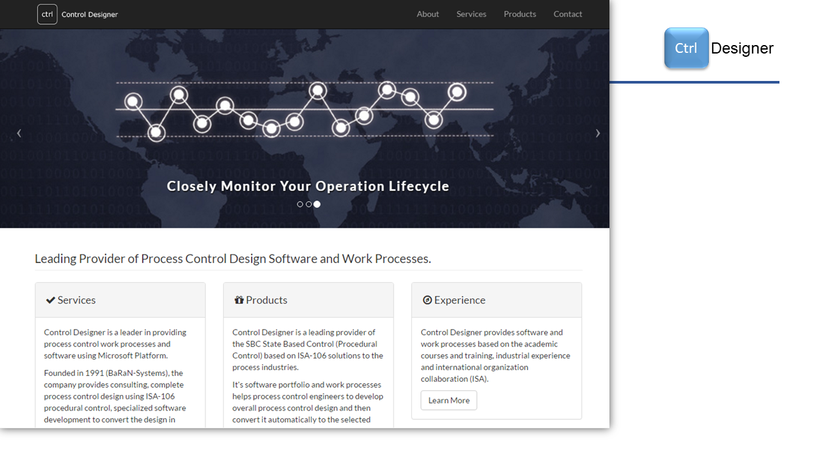 Copyright @ 2024 CTRL Designer LLC - CtrlDesigner.Com

## 1.2 CTRL Designer LLC (CDL)

Please review the following slide: 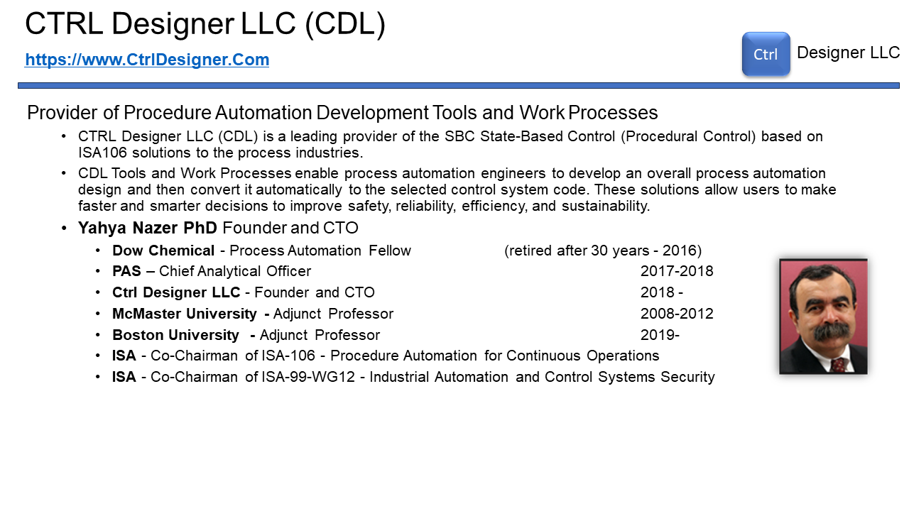 Copyright @ 2024 CTRL Designer LLC - CtrlDesigner.Com

## 1.3 Presentation Agenda

Please review the following slide: 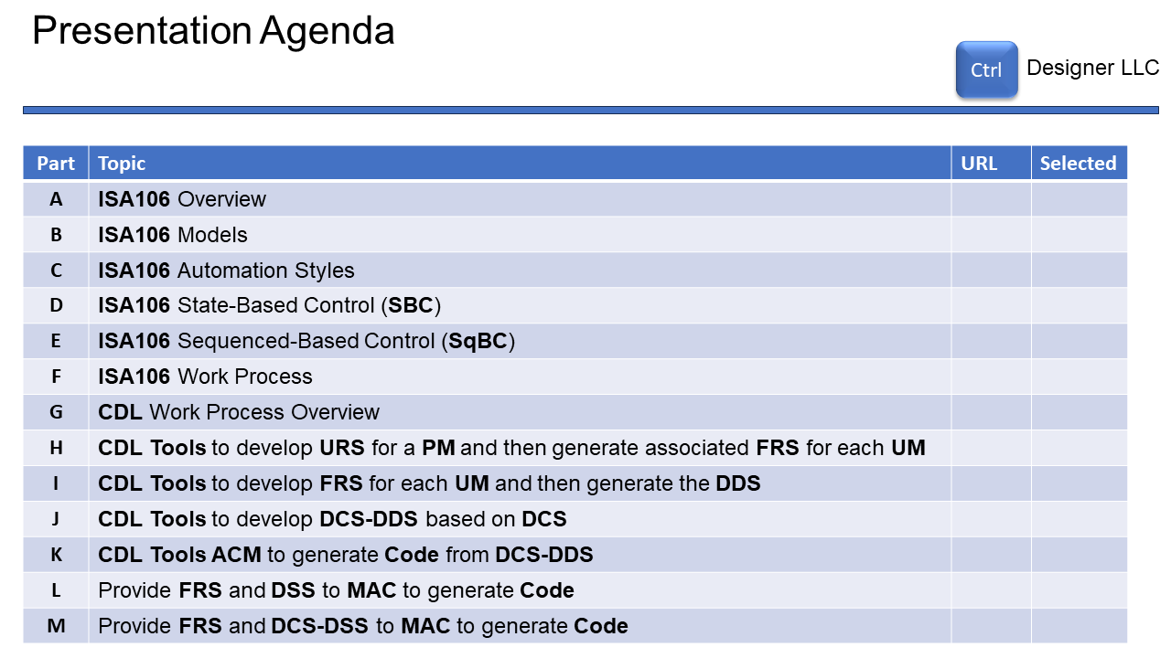 Copyright @ 2024 CTRL Designer LLC - CtrlDesigner.Com

## 1.4 Presentation Agenda

Please review the following slide: 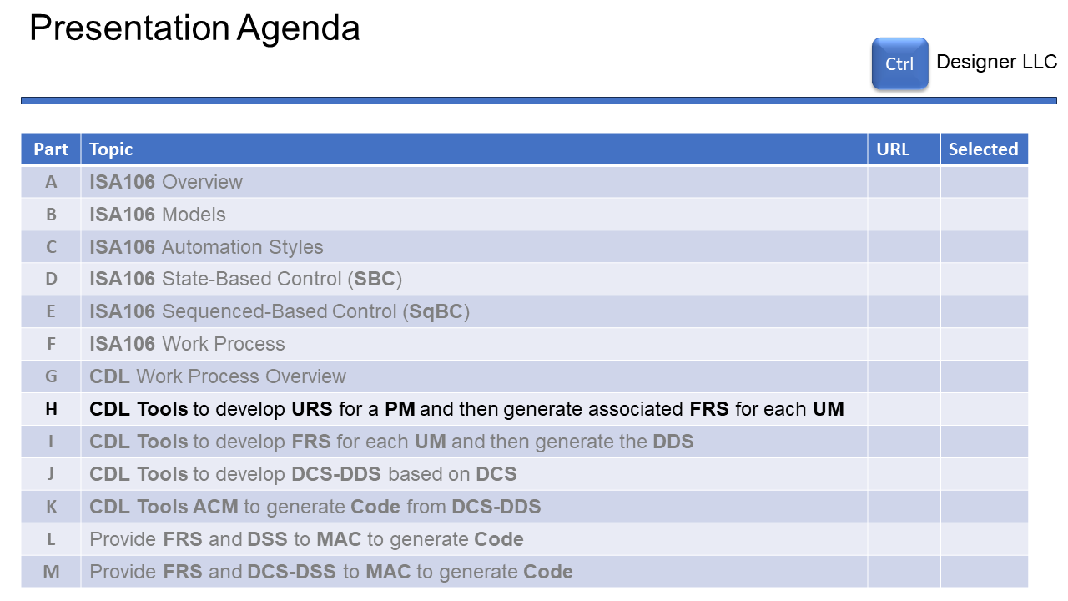 Copyright @ 2024 CTRL Designer LLC - CtrlDesigner.Com

## 1.5 CDL tools for Excel™

Please review the following slide: 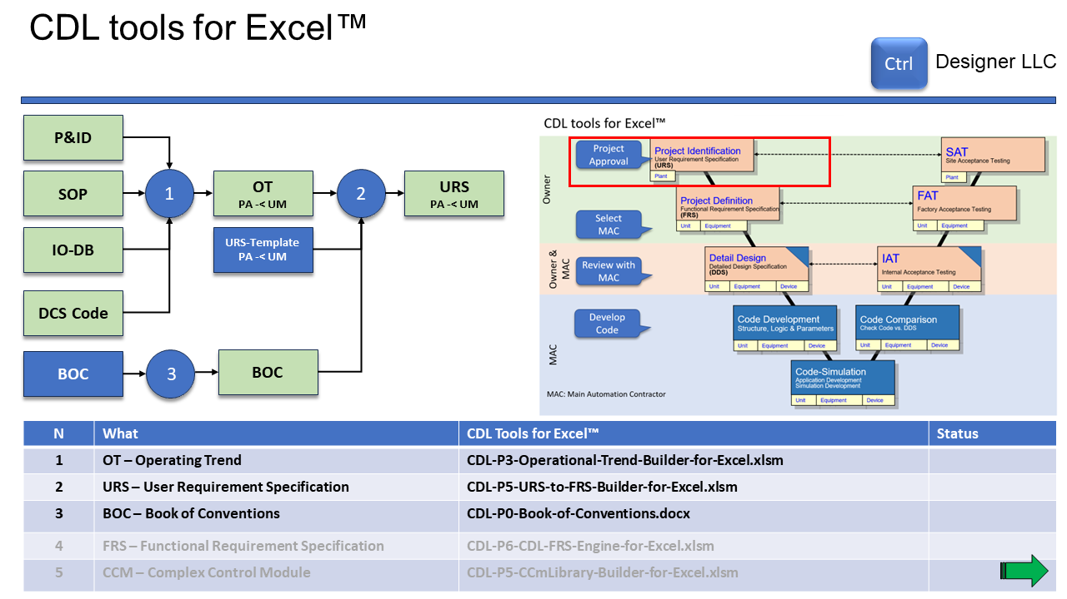 Copyright @ 2024 CTRL Designer LLC - CtrlDesigner.Com

## 1.6 CDL tools for Excel™ - CDL Engines

Please review the following slide: 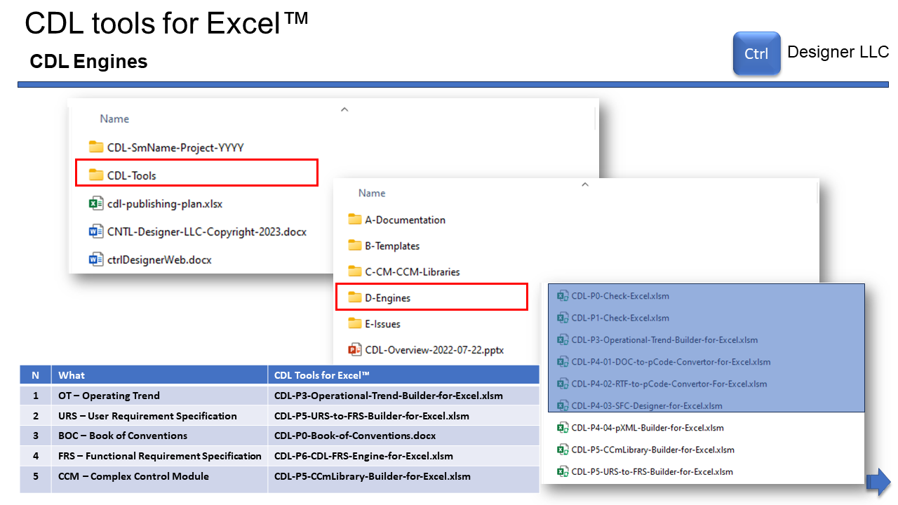 Copyright @ 2024 CTRL Designer LLC - CtrlDesigner.Com

## 1.7 CDL tools for Excel™ - CDL Project Folder

Please review the following slide: 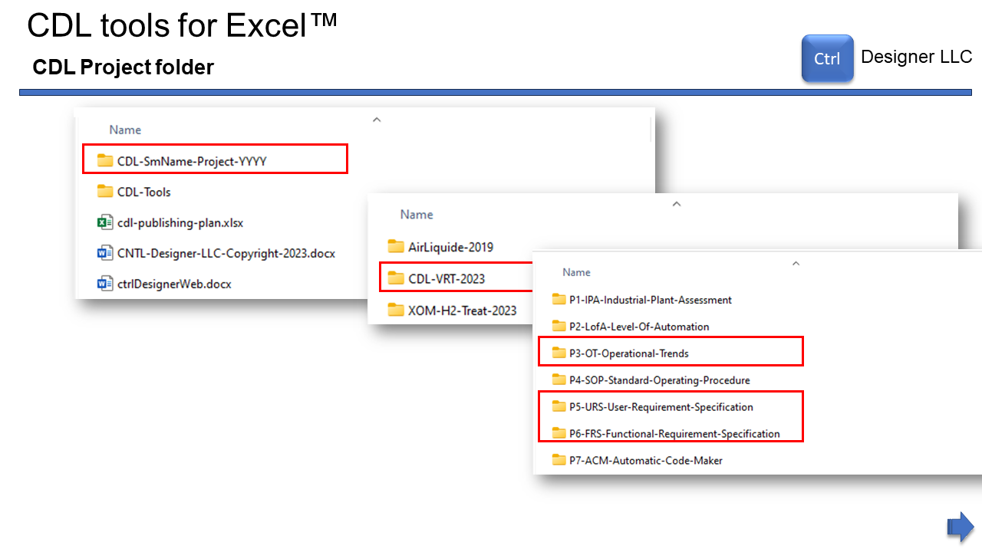 Copyright @ 2024 CTRL Designer LLC - CtrlDesigner.Com

## 1.8 CDL tools for Excel™ - CDL URS Engine

Please review the following slide: 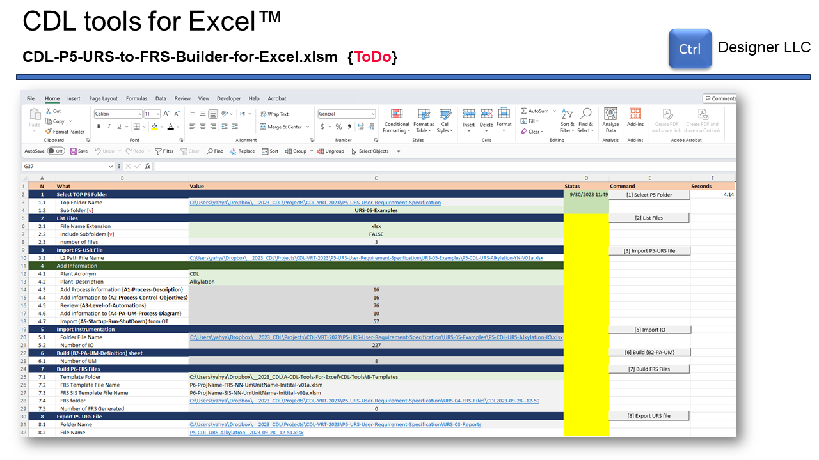 Copyright @ 2024 CTRL Designer LLC - CtrlDesigner.Com

## 1.9 CDL tools for Excel™ - CDL URS Tasks

Please review the following slide: 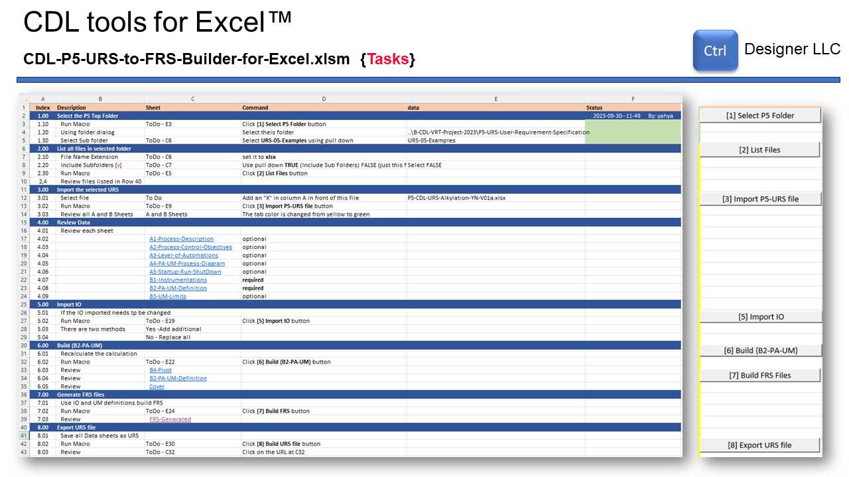 Copyright @ 2024 CTRL Designer LLC - CtrlDesigner.Com

## 1.10 CDL tools for Excel™ - Cover

Please review the following slide: 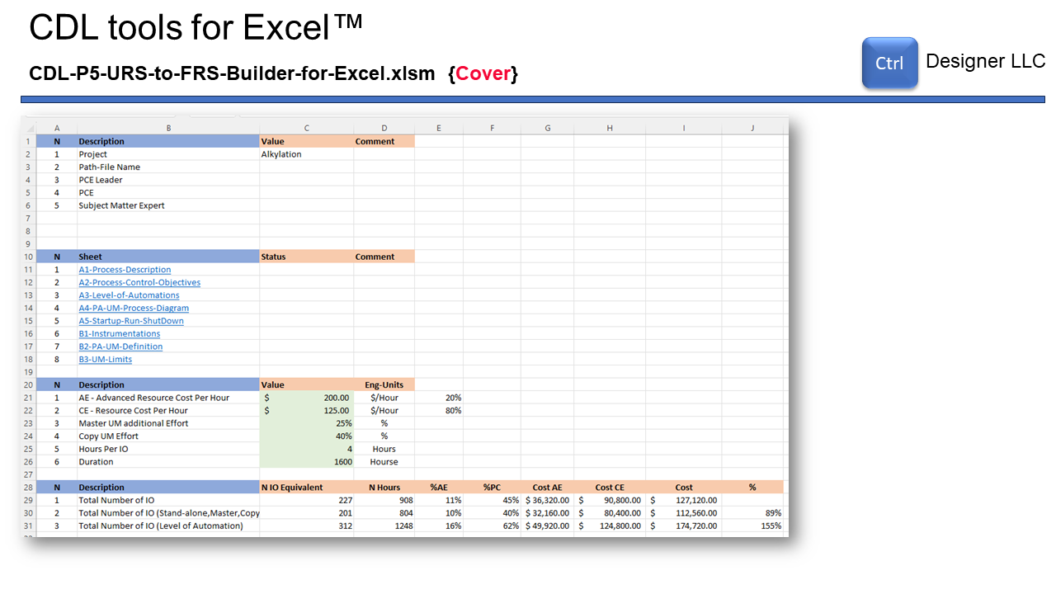 Copyright @ 2024 CTRL Designer LLC - CtrlDesigner.Com

## 1.11 CDL tools for Excel™ - Process Description

Please review the following slide: 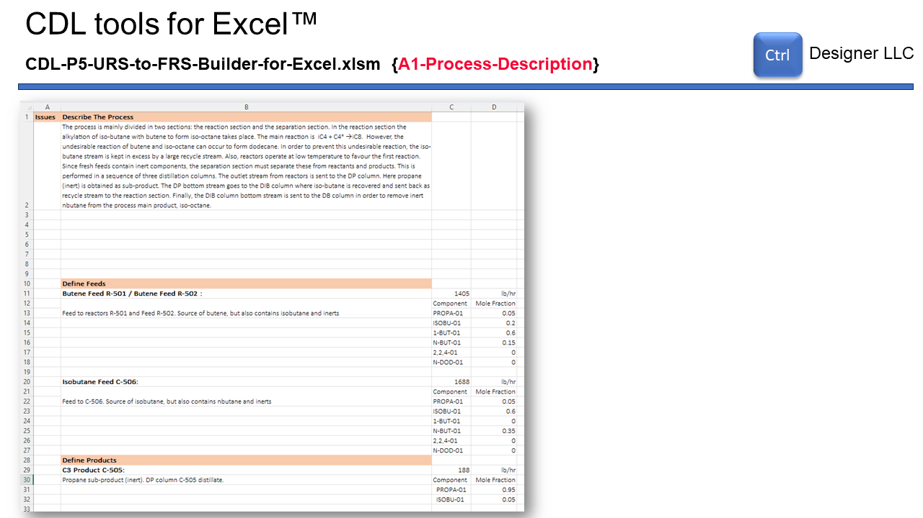 Copyright @ 2024 CTRL Designer LLC - CtrlDesigner.Com

## 1.12 CDL tools for Excel™ - Process Control Objective

Please review the following slide: 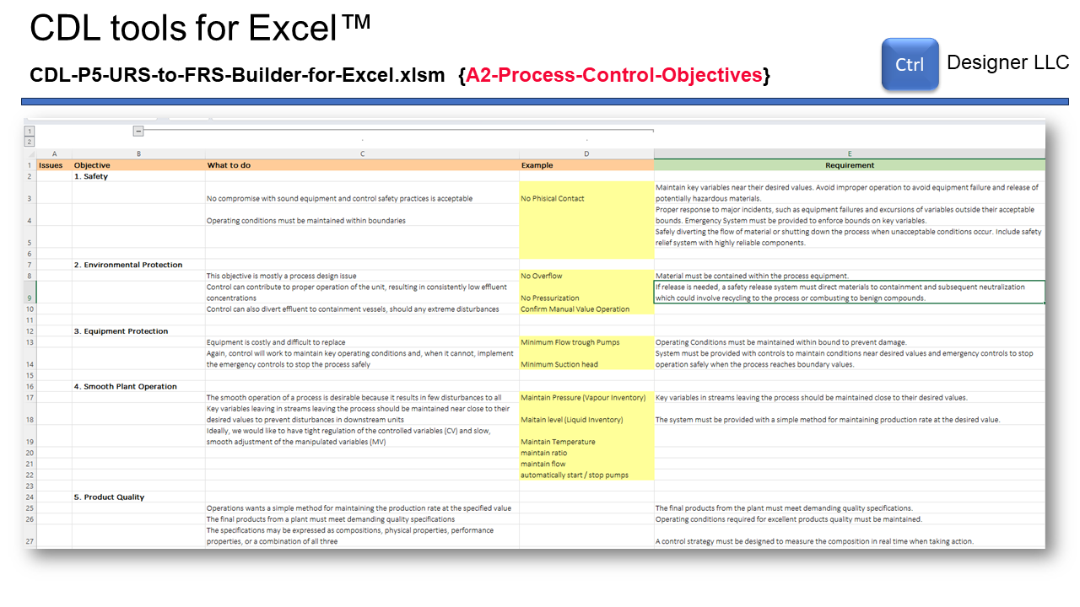 Copyright @ 2024 CTRL Designer LLC - CtrlDesigner.Com

## 1.13 CDL tools for Excel™ - Level of Automation

Please review the following slide: 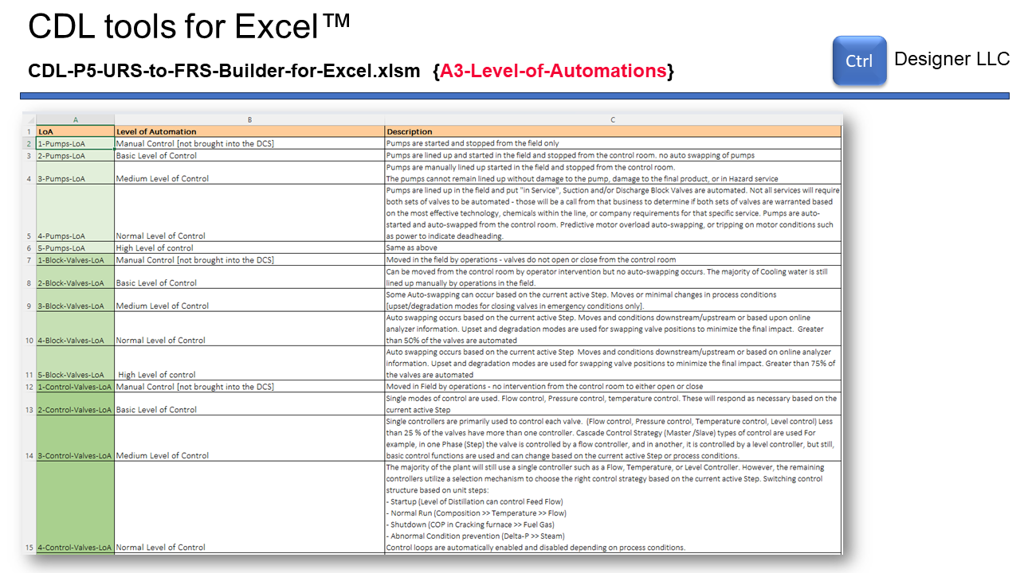 Copyright @ 2024 CTRL Designer LLC - CtrlDesigner.Com

## 1.14 CDL tools for Excel™ - Process Diagram

Please review the following slide: 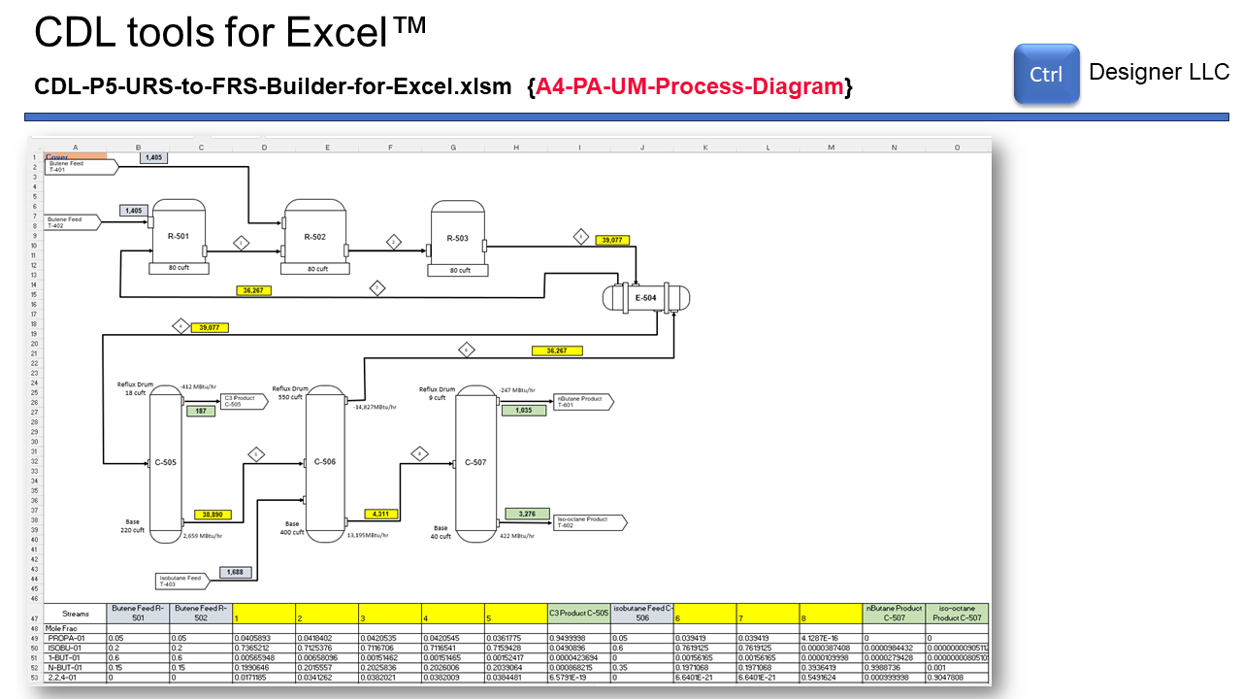 Copyright @ 2024 CTRL Designer LLC - CtrlDesigner.Com

## 1.15 CDL tools for Excel™

Please review the following slide: 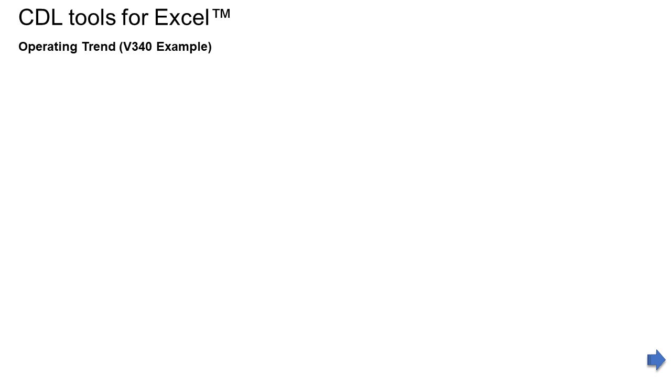 Copyright @ 2024 CTRL Designer LLC - CtrlDesigner.Com

## 1.16 CDL tools for Excel™ - Trends

Please review the following slide: 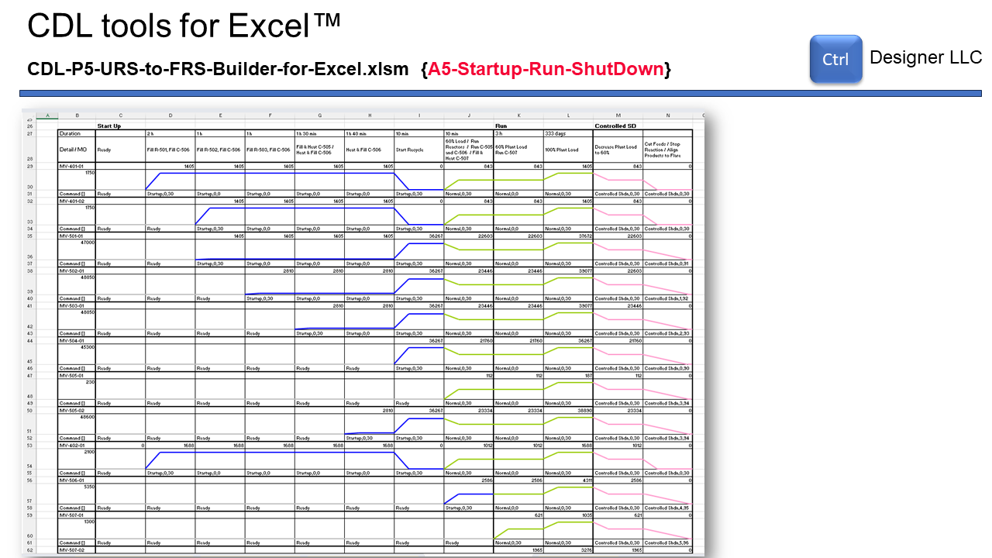 Copyright @ 2024 CTRL Designer LLC - CtrlDesigner.Com

## 1.17 CDL tools for Excel™ - Instrumentation

Please review the following slide: 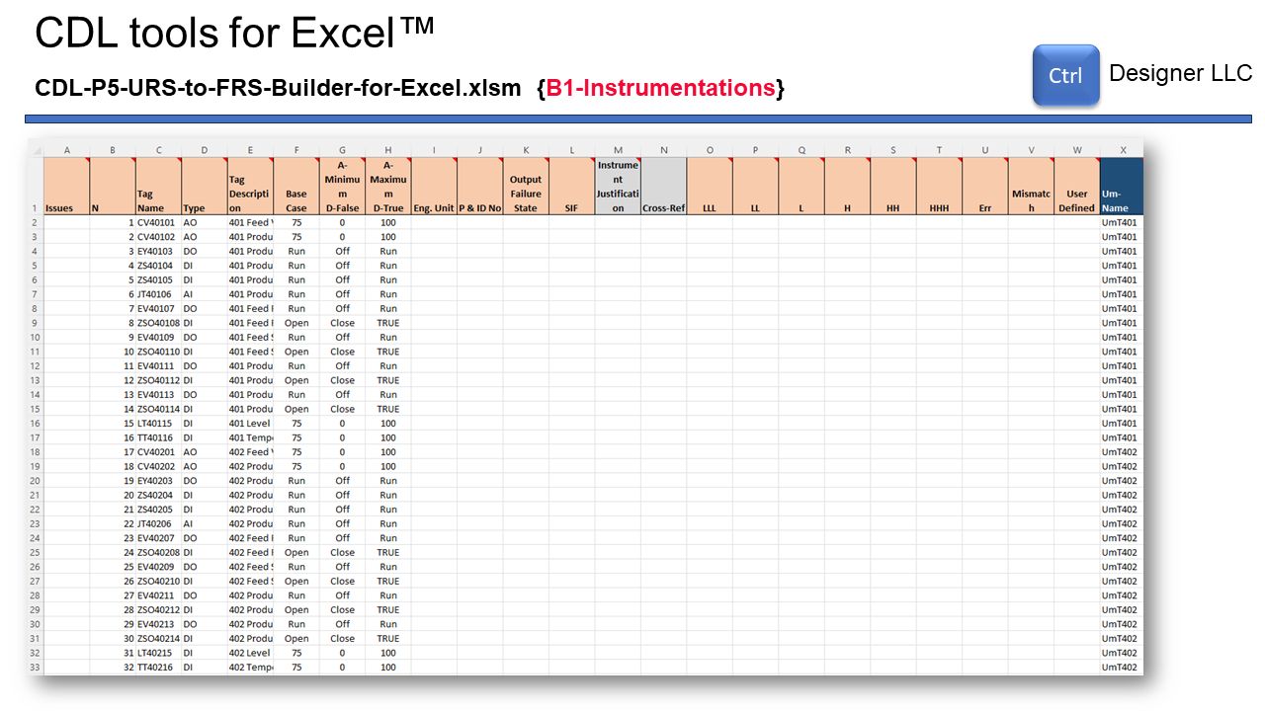 Copyright @ 2024 CTRL Designer LLC - CtrlDesigner.Com

## 1.18 CDL tools for Excel™ PA-UM definition

Please review the following slide: 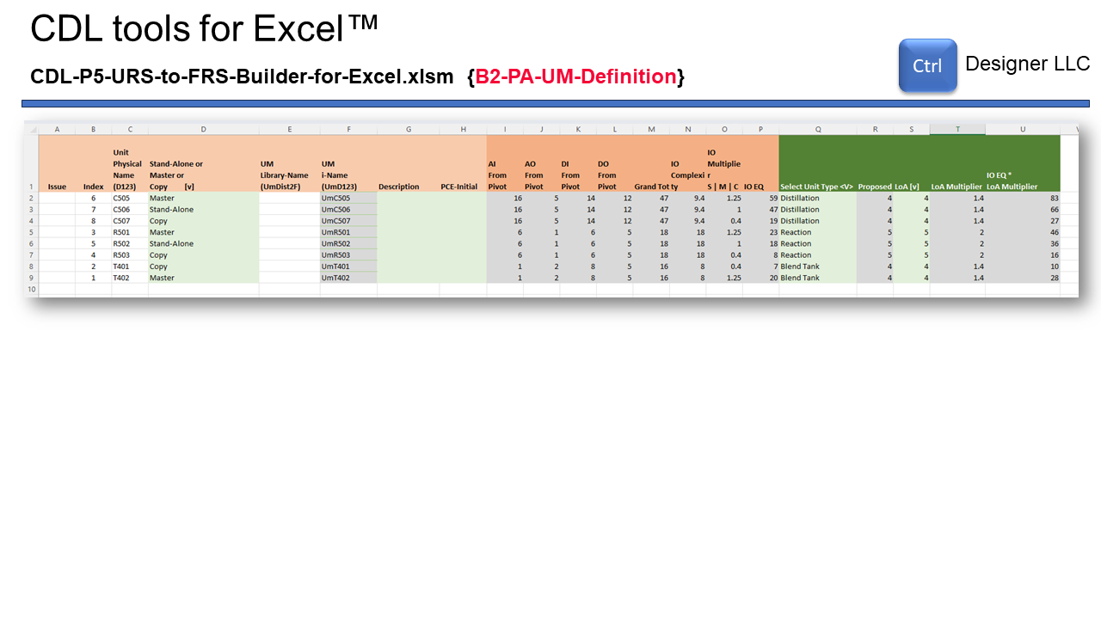 Copyright @ 2024 CTRL Designer LLC - CtrlDesigner.Com

## 1.19 CDL tools for Excel™ PA-Um Definition

Please review the following slide: 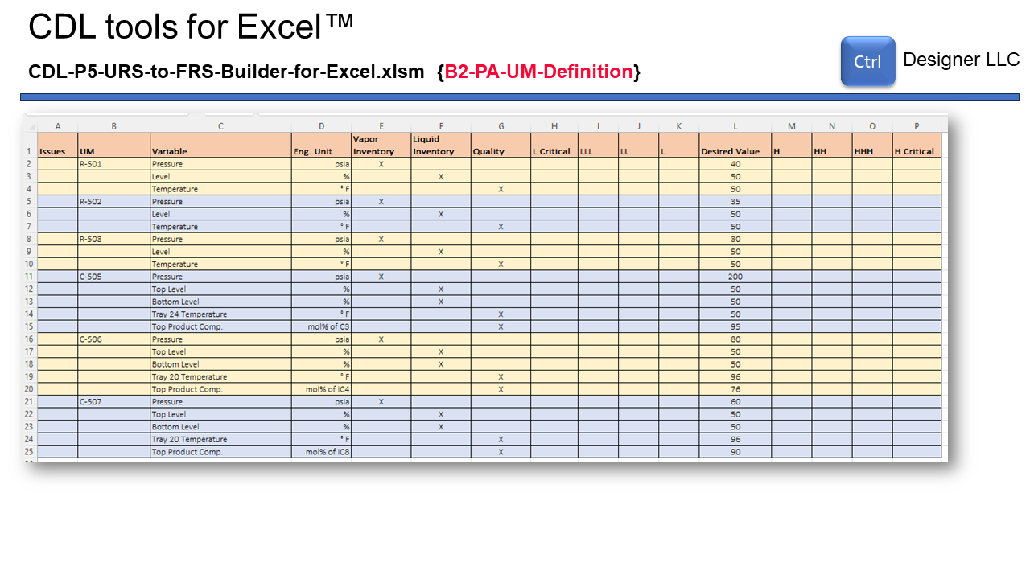 Copyright @ 2024 CTRL Designer LLC - CtrlDesigner.Com

## 1.20 CDL tools for Excel™ - Cover

Please review the following slide:  Copyright @ 2024 CTRL Designer LLC - CtrlDesigner.Com

## 1.21 CDL tools for Excel™ - Tool Overview

Please review the following slide: 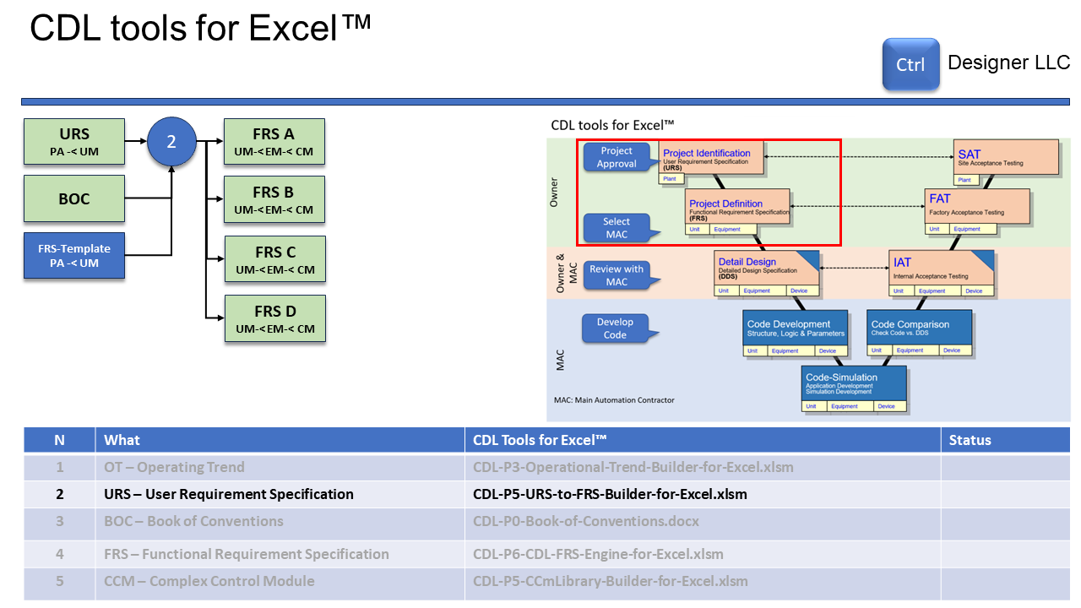 Copyright @ 2024 CTRL Designer LLC - CtrlDesigner.Com

## 1.22 CDL tools for Excel™ - FRS files generated

Please review the following slide: 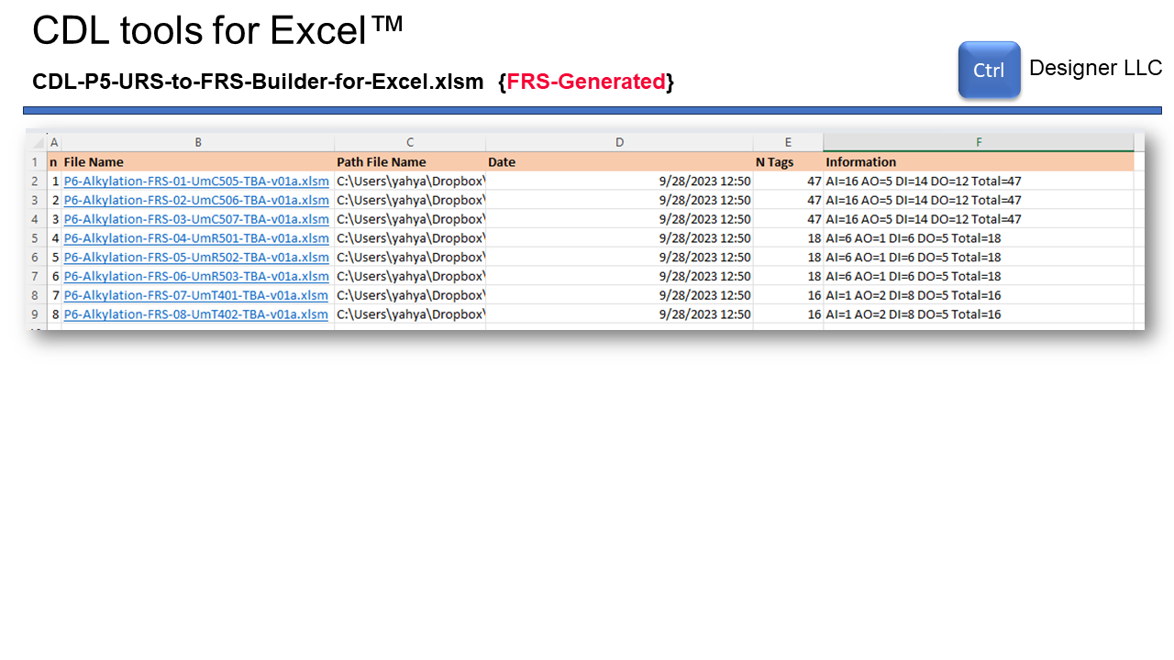 Copyright @ 2024 CTRL Designer LLC - CtrlDesigner.Com

## 1.23 Question and Answers

Please review the following slide: 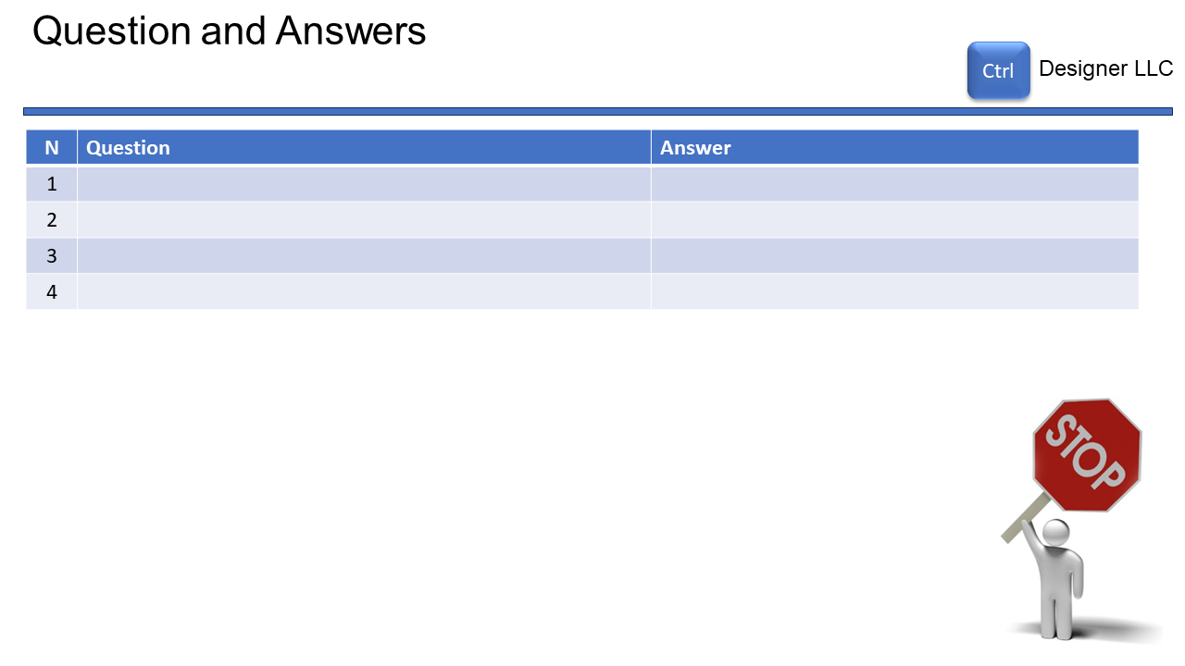 Copyright @ 2024 CTRL Designer LLC - CtrlDesigner.Com